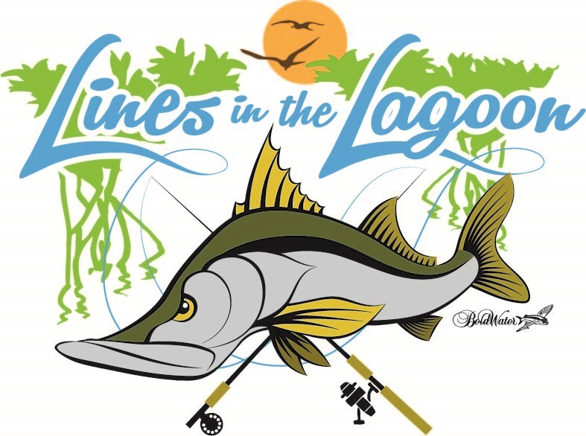
I hereby pledge the sum of $_________________________________ toward the junior fishing tournament Lines in the Lagoon and understand the proceeds will go to the Lines in the Lagoon (LITL), Ocean Research & Conservation Association (ORCA), and Coastal Conservation Association Florida (CCA Florida). LITL, ORCA and CCA Florida are 501(c) (3) not-for-profit organizations and all contributions made for this event are tax deductible as allowed by law.
___ Please sign me up as a gift in-kind sponsor.
I am donating ____________________________________________________ valued at $_____________________
Name:__________________________________________________________________________________________
Company (if applicable) ___________________________________________________________________________
Address: _________________________________________________________________________________________
Phone: ______________________________ Email:__________________________________________________
Form of payment - please check one:

□ Enclosed is a check made payable to “Lines in the Lagoon” in the amount of $ _________________________________

□ I will pay online at www.linesinthelagoon.com

Please follow up with me by phone at ____________________________________ if there are any questions.
Please write the name you want used for your sponsorship recognition:

__________________________________________________________________________________________________
SIGNATURE AMOUNT
_____________________________________________________________________ $________________________
□ Please keep my gift anonymous

Lines in the Lagoon ● P.O. Box 644071 ● Vero Beach, Fl 32964
(If you are submitting a check, please make it payable to Lines in the Lagoon) www.linesinthelagoon.com

Please submit your logo by August 20, 2023 If you are a SNOOK level sponsor or higher, we must have a logo in one of the following formats for t-shirt 1) Vector art is the best or 2) a HIGH Resolution PDF or JPEG 500 KB or better.

